**CS551 ADVANCED SOFTWARE ENGINEERING**

**PROJECT- THIRD INCREMENT- GROUP 4**

**OCCASIONS ON THE GO**

**Team Members:**

Prathyusha Dinne (16161128)

Anudeep Vattipalli (16158489)

Poojitha Mittapally(16157740)

**Introduction:**

Planning an event is very simple and is on high demand. To plan an event, you need to select every vendor, login to their websites and order the required services. Also, it will be difficult to adapt to different patterns and designs as each vendor has their own in built design. To avoid these problems, our project acts as a single stop where in user can find different vendors in one place with a common user interface (UI). This project provides feasibility to order services both through mobile and web applications. In this application, both users and vendors can take advantage as user will be provided with best deals and vendor can attract customers by giving offers.

**GitHub Link:**

<https://github.com/pdrk2/Increment3>

**ScrumDo Link:**

https://www.scrumdo.com/projects/project/one-stop/iteration/92458

**Implementation Status Report:**

**Work Completed till 3rd Increment:**

In third increment addition to what has been done in second increment, we have implemented search engine which allows users to search for content within the site. Other features which we have developed include delivery of mails to customers and vendors upon successful completion of order, checkout page consisting of all the orders, vendors can check for all the orders which are ordered by different customers and also vendors can view their monthly sale revenues through a bar chart graphical representation.

* Search Engine internal to our website for searching web content within the site
* Checkout page with all orders from the customer
* Graphical representation of monthly revenues of vendor sales
* Complete implementation of shopping cart
* SMTP mail client implementation
* Menus and Services edit pages for all vendors.
* Profile editing page for all vendors.
* Developed web service to retrieve login information and to register.
* Developed web service to retrieve menu items of all vendors.
* Profile editing pages for the users
* Vendors place will be shown on Google map
* User can add the items to the shopping cart
* User can view and remove the items from shopping cart

**Web Services:**

The web services which we developed were:

1. Order details
2. Vendor menus
3. Item find
4. Login web services

Order details web services have the following methods:

1. Adding user and vendor details respective to the order
2. Adding user order address details
3. User can view the orders
4. Vendor can view the orders

Vendor Menu and Item find web service has the following methods:

1. Adding Menu items (for Catering and Theme Vendors )
2. Editing Menu items
3. Retrieval of menu items
4. Adding services for vendors (for Photography and Venue Vendors)
5. Editing services for vendors
6. Search results to display the searching item

**Order Detials Table:**

This table consists of all queries Used for this table were:

a) insert into order_details (user_id,ven_id,details,total) values('" + user_id + "','" + ven_id + "','" + details + "','" + total + "');

b) UPDATE order_details SET email = '" + email + "', street = '" + street + "', city = '" + city + "', state = '" + state + "' , phone = '" + phone + "', date = '" + yDate + "' where id = '" + id + "'"

c) select * from order_details where ven_id = '" + ven_id + "'"

**Implementation of Services :**

Below services developed as part of this increment is:

1. Shopping Cart
2. Order of services for different vendors where vendors can view the order from customer to address them. And also customer can view their own orders
3. SMTP mail implementation, which is used to send mails to customers and vendors upon successful order of services.
4. Internal search engine to search the content of all data within our site
5. Vendors can view monthly revenue of sales through a bar graph

As part of user interface, we have implemented sliding of images on the web pages for effective web page view.

**Screenshots of Web Application:**

**User Profile:**

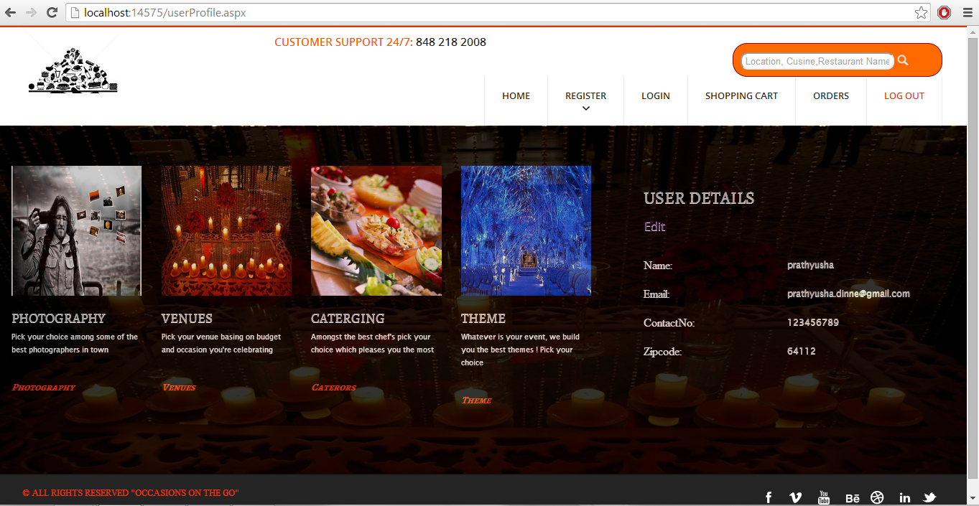

**Menu Display:**

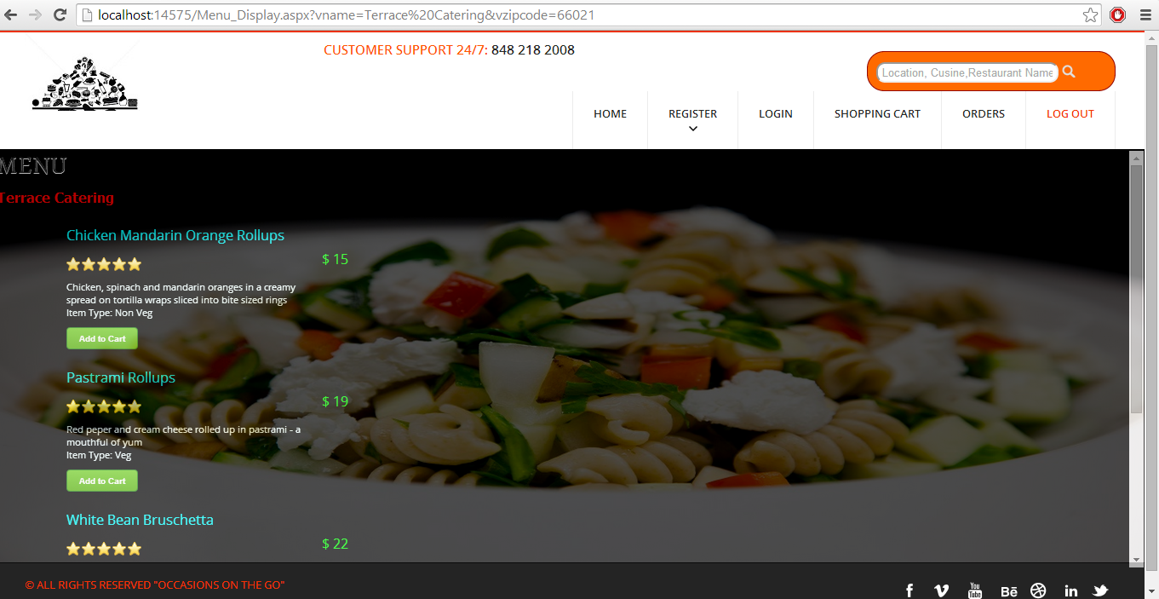

**Shopping Cart:**

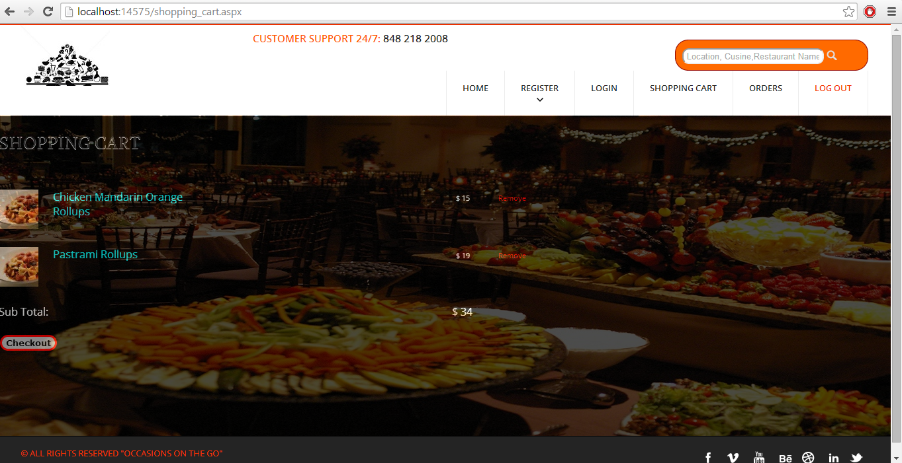

**Checkout Page:**

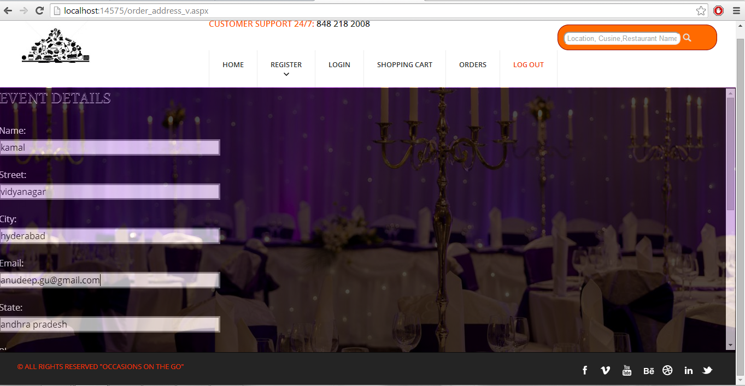

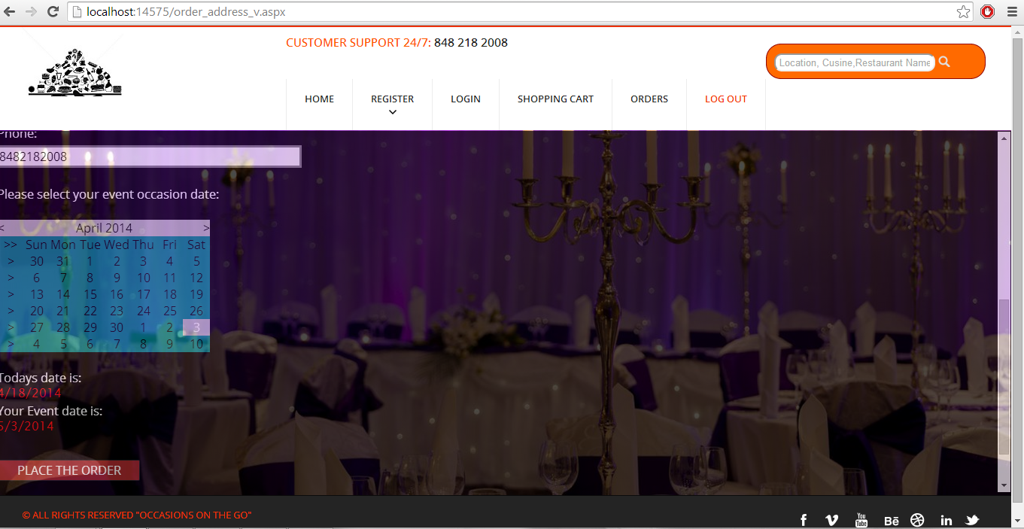

**Successful Completion Of Order:**

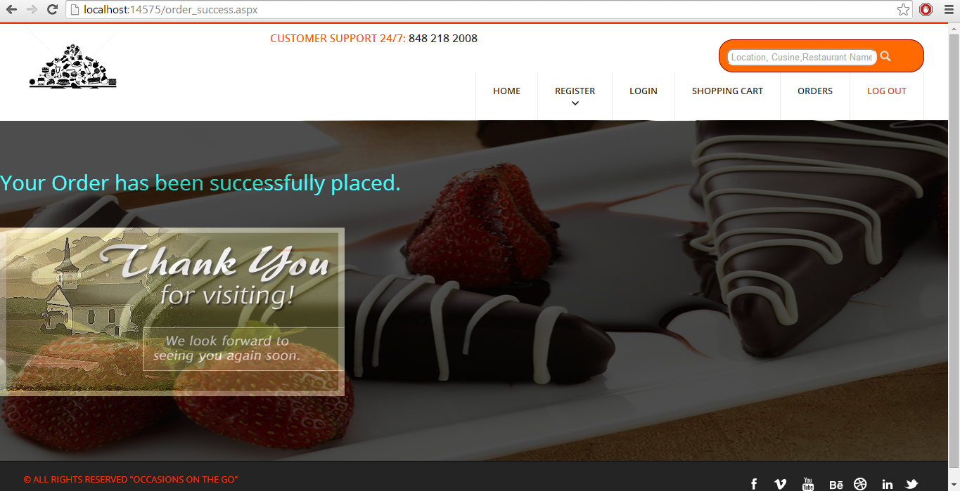

**Single Order Details for “JP Lighting Décor” shown in the above page:**

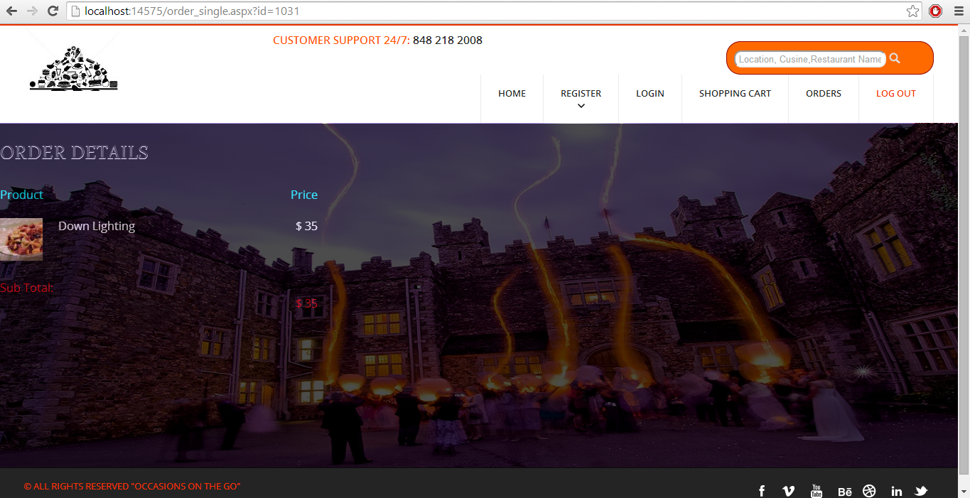

**Mail Confirmation:**

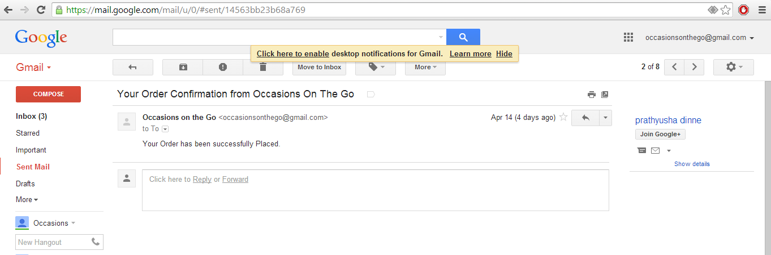

**User Order Page:**

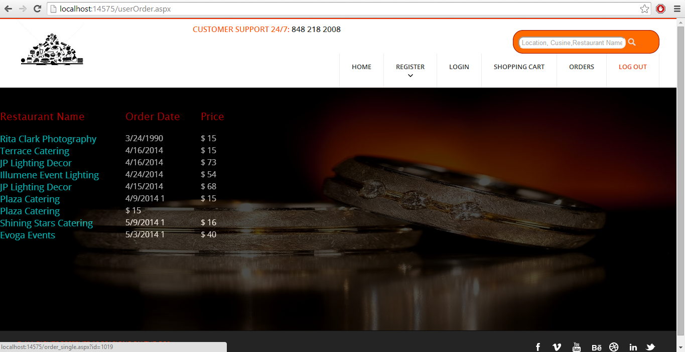

**Vendor Sales Graphical Representation Page:**

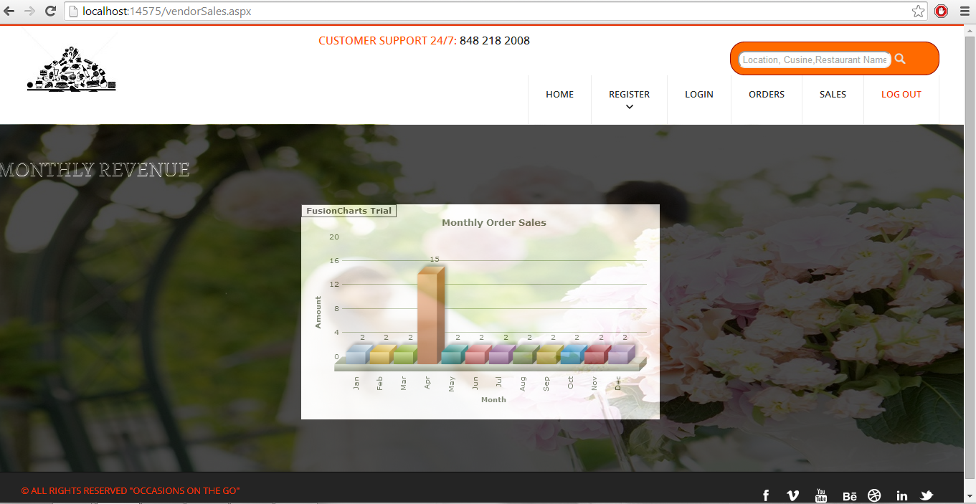

**Vendor View Of Orders from Different Customers:**

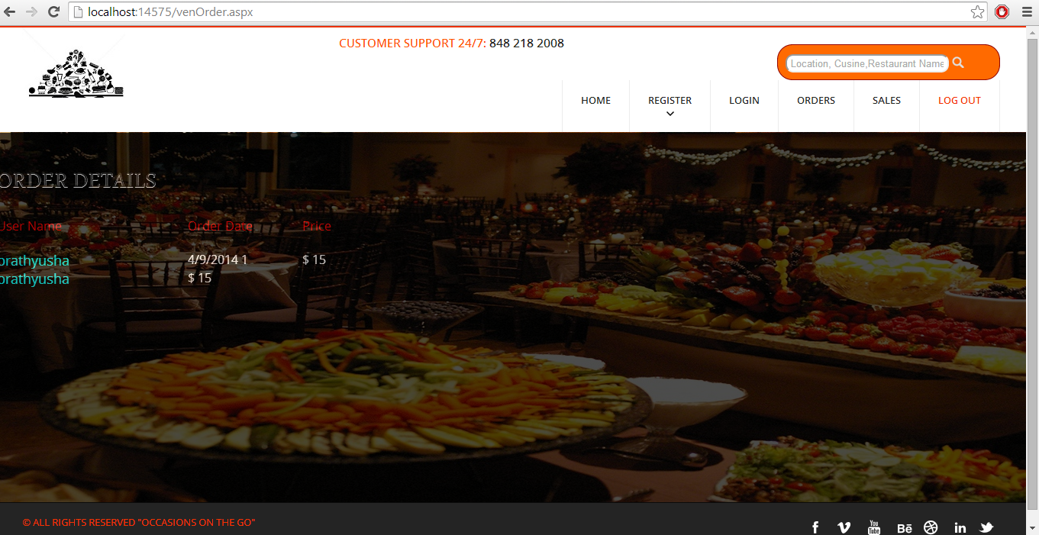

**Clicking On The User Vendor Can View Details Of The User’s Order:**

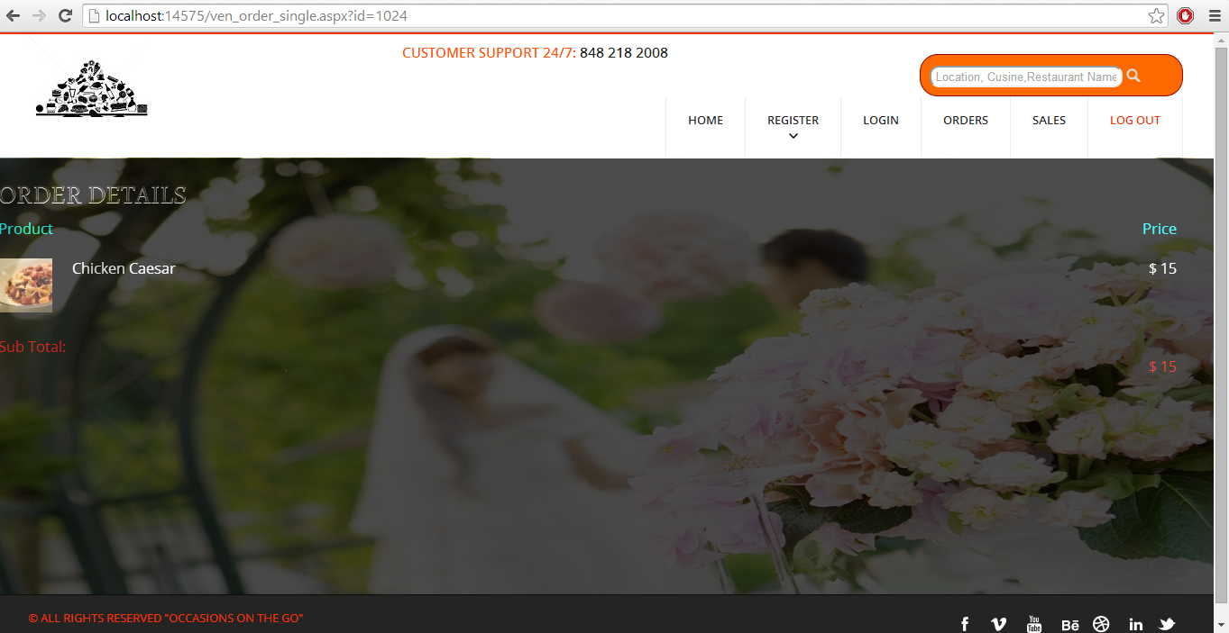

**Search Results Page:**

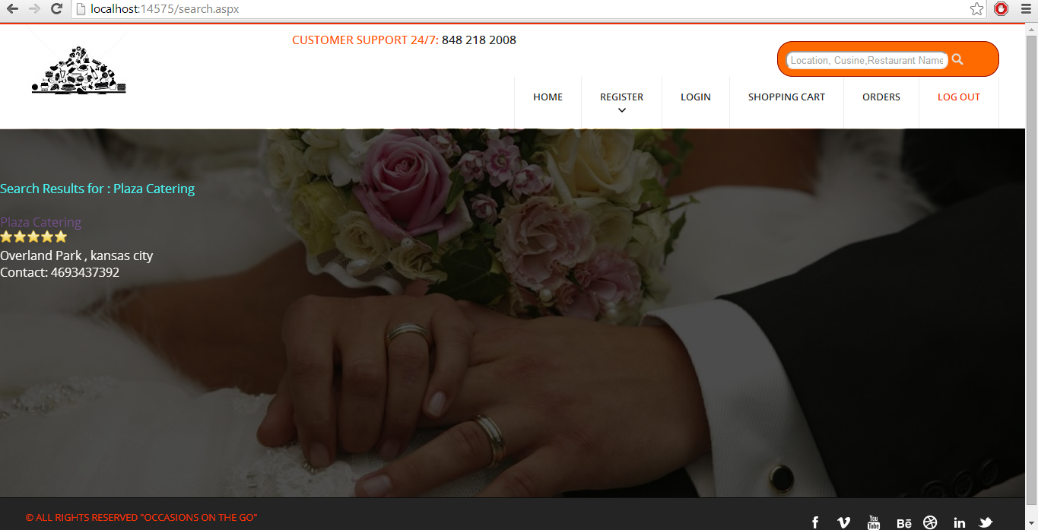

**Work Completed As Part Of 3rd Increment:**

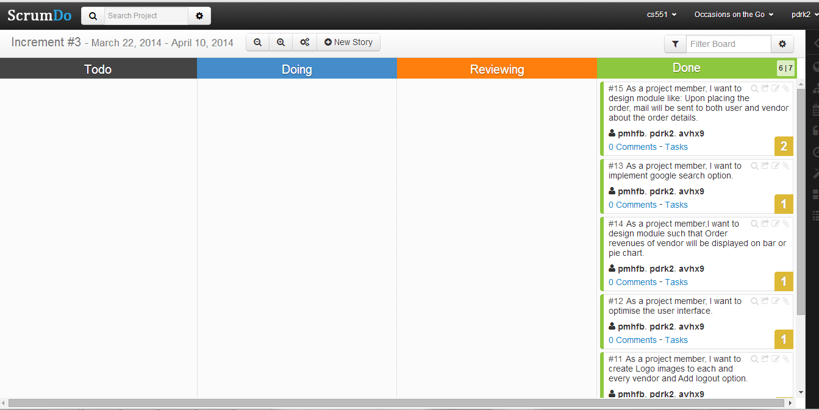

**Responsibilities:**

|  |  |  |  |
| --- | --- | --- | --- |
| **Sl.No** | **Task** | **Person involved** | **Estimated Time** |
| 1. | Upon placing the order, mail will be sent to both user and vendor about the order details. | Prathyusha  Anudeep | 8 hours |
| 2. | Order revenues of vendor will be displayed on bar or pie chart | Prathyusha  Anudeep  Poojitha | 6 hours |
| 3. | Implementing search engine option | Poojitha | 2 hours |
| 4. | Further enhancements to second increment have been implemented. | Prathyusha  Poojitha  Anudeep | 6 hours |
| 5. | Logo images have been inserted to each and every vendor. | Poojitha | 5 hours |
| 6. | Optimized the UI | Prathyusha | 2 hours |
| 7. | Testing | Anudeep | 2 hours |

**Work to be completed in 4th increment:**

**Responsibilities:**

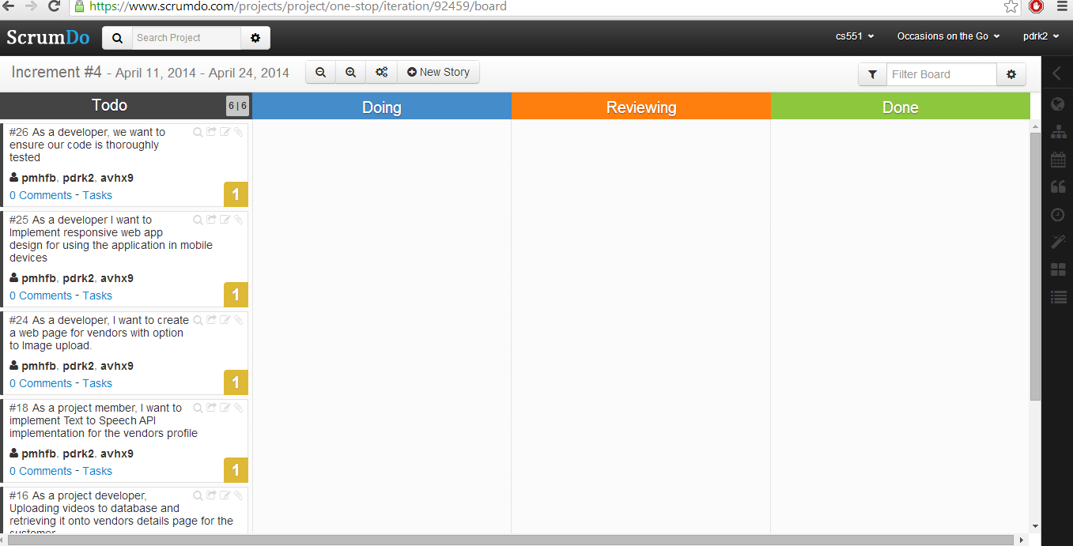

|  |  |  |
| --- | --- | --- |
| **Sl.No** | **Task** | **Person involved** |
| 1. | Text to Speech API implementation for the vendors profile | Prathyusha  Poojitha |
| 2. | Uploading videos to database and retrieving it onto vendors details page for the customer | Prathyusha  Anudeep |
| 3. | Integrating weather API to view weather updates on occasion date | Prathyusha  Poojitha |
| 4. | Image upload option for vendors. | Anudeep  Prathyusha |
| 5. | Implement responsive web app design for using the application in mobile devices | Prathyusha  Anudeep |
| 6. | Further addition of features which can be implemented | Prathyusha  Anudeep  Poojitha |
| 7. | Testing | Anudeep |
| 8. | Documentation | Prathyusha  Anudeep  Poojitha |